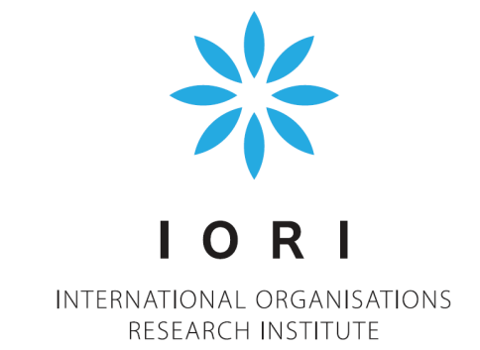 | 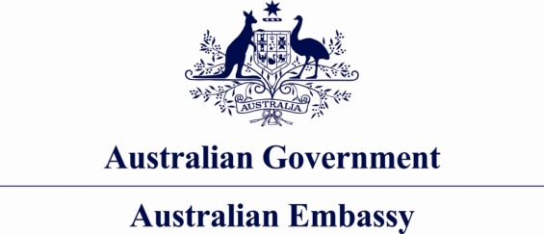  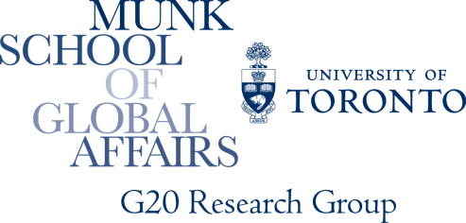

Strengthening Global Summitry:
Accountability for Effectiveness and Legitimacy in the G8 and G20
Global Summit Governance Conference
May 19, 2014
Venue: Higher School of Economics, Conference Room 311
20 Myasnitskaya str., Moscow, Russia,
Working Language: English

9:00–9:30 Registration and Welcome Coffee

9:30–10:15 Opening Remarks

Alexander Shokhin, President, National Research University Higher School of Economics

G20 Contribution to Global Governance

Svetlana Lukash, Russian G20 Sherpa

Russia’s Contribution to Global Governance

Dr Alexey Kvasov, Deputy Head, Presidential Experts’ Directorate

10:15–12:00 Governing Global Economy

Chair: Sergey Afontsev, Director, Economic Theory Department, Institute for World Economy and International Relations (IMEMO)

Global Economic Challenges and Governance Responses

Dr Evsey Gurvich, Head, Economic Expert Group (EEG), Member, Presidential Economic Council, Deputy Chair, Public Council at the Ministry of Finance of the Russian Federation

Governing the Global Crisis

Professor Anthony Payne, Department of Politics, University of Sheffield

The Changing Relationship between Financial Stability Policy and Monetary Policy

Professor Andrew Baker, Reader, Queen’s University of Belfast

Governing Global Trade

Dr Alexander Daniltsev, Director, Institute of Trade Policy, Professor, Department of Trade Policy, Faculty of World Economy and International Affairs, National Research University Higher School of Economics

Governing Global Tax Policy

Dr Dries Lesage, Professor, Department of Political Science, Ghent University

12:00–12:15 Break

12:15–13:15 Governing Global Society

Chairs: Professor Leonid Grigoriev, Head, Department of World Economy, Faculty of World Economy and International Affairs, Chief Research Fellow, Center for Comprehensive European and International Studies (CCEIS), National Research University Higher School of Economics and Victor Mizin, Deputy Director, Institute for Strategic Assessments

G8-G20-BRICS Engagement

Dr Marek Rewizorski, Adjunct, Koszalin University of Technology

Governing Climate Change

Dr Ella Kokotsis, Director of Accountability, G8 & G20 Research Groups, Munk School of Global Affairs, University of Toronto

Governing Global Energy

Dr Victoria Panova, Associate Professor, Department of International Relations and Foreign Policy of Russia, MGIMO-University

13:15–14:00 Lunch and Author’s Workshop

14:00–15:30 Governing Global Security

Chair: Dr Maxim Bratersky, Acting Department Head, Professor, Department of International Affairs, Faculty of World Economy and International Affairs, Leading Research Fellow, Center for Comprehensive European and International Studies (CCEIS), National Research University Higher School of Economics

Governing Global Terrorism

Dmitry Suslov, Senior Lecturer, Department of International Affairs, Faculty of World Economy and International Affairs, Deputy Director, Center for Comprehensive European and International Studies (CCEIS), National Research University Higher School of Economics

Governing Global Drug Control: Afghanistan and Beyond

Ilnur Batyrshin, Head, Research Center, Federal Drug Control Service of the Russian Federation

Governing Regional Conflicts: Kosovo, Libya, Mali, Syria and Beyond

John Kirton, Director, G8 Research Group, Co-director, G20 Research Group, Co-director, BRICS Research Group, Munk School of Global Affairs, University of Toronto

15:30-15:45 Break

15:45-17:00 Strengthening Summit Accountability

Chair: Dr Marina Larionova, Head, International Organizations Research Institute, National Research University Higher School of Economics

The G8 and G20 Accountability Working Group Contributions

Andrey Bokarev, Director, Department of International Financial Relations,

Ministry of Finance of the Russian Federation

The G8 and G20 Research Groups-HSE Compliance Assessments

Mark Rakhmangulov, Deputy Director, Andrei Sakharov, Researcher, Global Governance Research Center, International Organizations Research Institute, National Research University Higher School of Economics, and Caroline Bracht, G8 and G20 Research Groups, Munk School of Global Affairs, University of Toronto

Engaging with Business for Effective Governance and Accountability

Andrey Shelepov, Researcher, Global Governance Research Center, International Organizations Research Institute, National Research University Higher School of Economics

The Young Entrepreneurs Alliance Accountability Assessment

Victor Sedov, President, Centre for Entrepreneurship (Russia), Chairman, G20 Young Entrepreneurs' Alliance 2013 – 2014 and Igor Egorov, Director, St. Petersburg office, Center for Entrepreneurship

17:00-18:00 Concluding Reflections

Chair: John Kirton, Director, G8 Research Group, Co-director, G20 Research Group, Co-director, BRICS Research Group, Munk School of Global Affairs, University of Toronto

Antonio José Vallim Guerreiro, Ambassador of the Federative Republic of Brazil to the Russian Federation

Paul Myler, Ambassador of Australia to the Russian Federation

Aydın Adnan Sezgin, Ambassador of the Republic of Turkey to the Russian Federation

Marina Larionova, Head, International Organizations Research Institute, National Research University Higher School of Economics

18:00-19:30 Reception

The Reception is hosted by Ambassador of Australia to the Russian Federation, His Excellency Paul Myler.

Residence address is: Shekhtel Mansion, 13 Kropotkinsky Pereulok, Moscow

Transfer to the reception will be organized from the place of the conference venue.

